coord=index, species=big skate, area=CA

Regression Plot
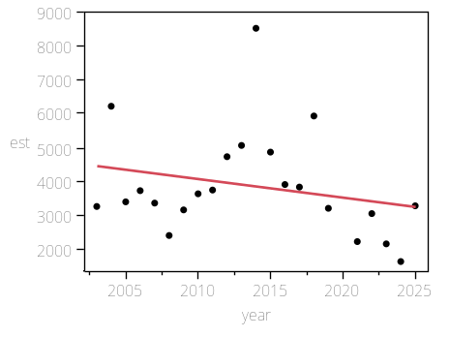

Summary of Fit

RSquare | 0.058416
RSquare Adj | 0.011337
Root Mean Square Error | 1536.21
Mean of Response | 3871.539
Observations (or Sum Wgts) | 22

AICc | 390.501
BIC | 392.4408

Analysis of Variance

Source | DF | Sum of Squares | Mean Square | F Ratio
Model | 1 | 2928243 | 2928243 | 1.2408
Error | 20 | 47198816 | 2359941 | Prob > F
C. Total | 21 | 50127059 |  | 0.2785

Parameter Estimates

Term | Estimate | Std Error | t Ratio | Prob>|t| | Lower 95% | Upper 95%
Intercept | 114265.09 | 99104.42 | 1.15 | 0.2625 | -92463.12 | 320993.29
year | -54.82051 | 49.21415 | -1.11 | 0.2785 | -157.4794 | 47.83842

coord=index, species=big skate, area=Coastwide

Regression Plot
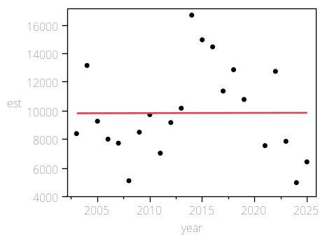

Summary of Fit

RSquare | 9.447e-6
RSquare Adj | -0.04999
Root Mean Square Error | 3280.146
Mean of Response | 9854.001
Observations (or Sum Wgts) | 22

AICc | 423.8781
BIC | 425.8179

Analysis of Variance

Source | DF | Sum of Squares | Mean Square | F Ratio
Model | 1 | 2033 | 2032.9612 | 0.0002
Error | 20 | 215187143 | 10759357 | Prob > F
C. Total | 21 | 215189176 |  | 0.9892

Parameter Estimates

Term | Estimate | Std Error | t Ratio | Prob>|t| | Lower 95% | Upper 95%
Intercept | 6945.263 | 211609.7 | 0.03 | 0.9741 | -434464.9 | 448355.44
year | 1.444455 | 105.083 | 0.01 | 0.9892 | -217.7549 | 220.64384

coord=index, species=big skate, area=North of Cape Mendocino

Regression Plot
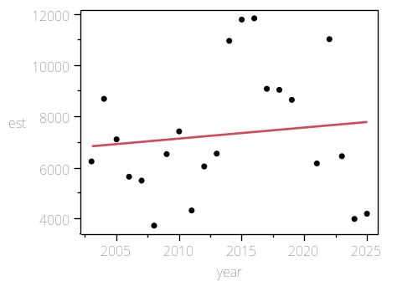

Summary of Fit

RSquare | 0.013739
RSquare Adj | -0.03557
Root Mean Square Error | 2551.982
Mean of Response | 7309.812
Observations (or Sum Wgts) | 22

AICc | 412.8333
BIC | 414.7731

Analysis of Variance

Source | DF | Sum of Squares | Mean Square | F Ratio
Model | 1 | 1814424 | 1814424 | 0.2786
Error | 20 | 130252201 | 6512610 | Prob > F
C. Total | 21 | 132066625 |  | 0.6034

Parameter Estimates

Term | Estimate | Std Error | t Ratio | Prob>|t| | Lower 95% | Upper 95%
Intercept | -79588.14 | 164634.2 | -0.48 | 0.6340 | -423009 | 263832.76
year | 43.152791 | 81.7555 | 0.53 | 0.6034 | -127.3862 | 213.69179

coord=index, species=big skate, area=North of Monterey Bay

Regression Plot
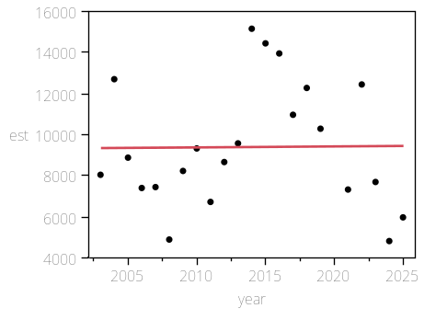

Summary of Fit

RSquare | 0.000114
RSquare Adj | -0.04988
Root Mean Square Error | 3087.605
Mean of Response | 9393.63
Observations (or Sum Wgts) | 22

AICc | 421.2164
BIC | 423.1562

Analysis of Variance

Source | DF | Sum of Squares | Mean Square | F Ratio
Model | 1 | 21772 | 21772 | 0.0023
Error | 20 | 190666061 | 9533303 | Prob > F
C. Total | 21 | 190687833 |  | 0.9624

Parameter Estimates

Term | Estimate | Std Error | t Ratio | Prob>|t| | Lower 95% | Upper 95%
Intercept | -125.4292 | 199188.5 | -0.00 | 0.9995 | -415625.3 | 415374.43
year | 4.7270845 | 98.91477 | 0.05 | 0.9624 | -201.6055 | 211.05969

coord=index, species=big skate, area=OR

Regression Plot
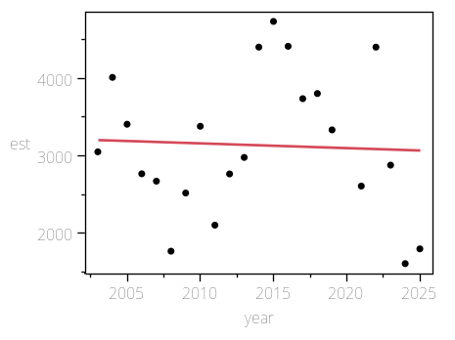

Summary of Fit

RSquare | 0.002098
RSquare Adj | -0.0478
Root Mean Square Error | 929.6852
Mean of Response | 3141.206
Observations (or Sum Wgts) | 22

AICc | 368.403
BIC | 370.3428

Analysis of Variance

Source | DF | Sum of Squares | Mean Square | F Ratio
Model | 1 | 36337 | 36337 | 0.0420
Error | 20 | 17286292 | 864315 | Prob > F
C. Total | 21 | 17322628 |  | 0.8396

Parameter Estimates

Term | Estimate | Std Error | t Ratio | Prob>|t| | Lower 95% | Upper 95%
Intercept | 15438.568 | 59976.13 | 0.26 | 0.7995 | -109669.4 | 140546.57
year | -6.106766 | 29.78348 | -0.21 | 0.8396 | -68.23401 | 56.020477

coord=index, species=big skate, area=South of Cape Mendocino

Regression Plot
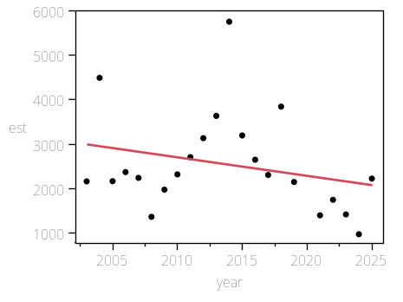

Summary of Fit

RSquare | 0.065163
RSquare Adj | 0.018421
Root Mean Square Error | 1102.645
Mean of Response | 2544.189
Observations (or Sum Wgts) | 22

AICc | 375.9103
BIC | 377.8501

Analysis of Variance

Source | DF | Sum of Squares | Mean Square | F Ratio
Model | 1 | 1694989 | 1694989 | 1.3941
Error | 20 | 24316506 | 1215825 | Prob > F
C. Total | 21 | 26011494 |  | 0.2516

Parameter Estimates

Term | Estimate | Std Error | t Ratio | Prob>|t| | Lower 95% | Upper 95%
Intercept | 86533.403 | 71134.14 | 1.22 | 0.2380 | -61849.81 | 234916.62
year | -41.70834 | 35.32442 | -1.18 | 0.2516 | -115.3938 | 31.977115

coord=index, species=big skate, area=South of Monterey Bay

Regression Plot
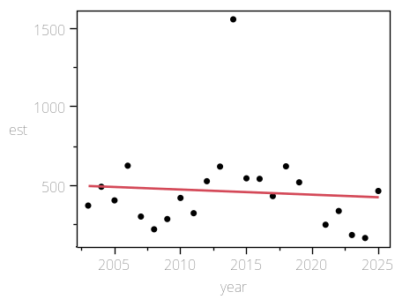

Summary of Fit

RSquare | 0.006198
RSquare Adj | -0.04349
Root Mean Square Error | 290.1326
Mean of Response | 460.3716
Observations (or Sum Wgts) | 22

AICc | 317.1647
BIC | 319.1045

Analysis of Variance

Source | DF | Sum of Squares | Mean Square | F Ratio
Model | 1 | 10499.4 | 10499.4 | 0.1247
Error | 20 | 1683538.3 | 84176.9 | Prob > F
C. Total | 21 | 1694037.7 |  | 0.7277

Parameter Estimates

Term | Estimate | Std Error | t Ratio | Prob>|t| | Lower 95% | Upper 95%
Intercept | 7070.6921 | 18717.12 | 0.38 | 0.7096 | -31972.53 | 46113.918
year | -3.282629 | 9.294713 | -0.35 | 0.7277 | -22.67106 | 16.105802

coord=index, species=big skate, area=WA

Regression Plot
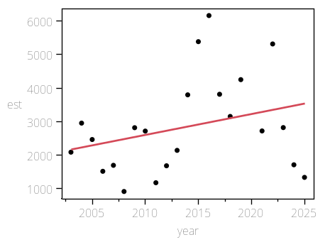

Summary of Fit

RSquare | 0.087402
RSquare Adj | 0.041773
Root Mean Square Error | 1406.731
Mean of Response | 2841.257
Observations (or Sum Wgts) | 22

AICc | 386.6269
BIC | 388.5667

Analysis of Variance

Source | DF | Sum of Squares | Mean Square | F Ratio
Model | 1 | 3790501 | 3790501 | 1.9155
Error | 20 | 39577854 | 1978893 | Prob > F
C. Total | 21 | 43368355 |  | 0.1816

Parameter Estimates

Term | Estimate | Std Error | t Ratio | Prob>|t| | Lower 95% | Upper 95%
Intercept | -122758.4 | 90751.46 | -1.35 | 0.1913 | -312062.6 | 66545.835
year | 62.371727 | 45.06616 | 1.38 | 0.1816 | -31.63464 | 156.3781

coord=index, species=dogfish, area=CA

Regression Plot
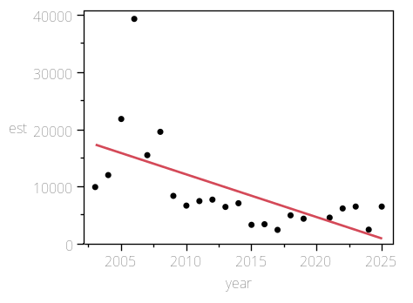

Summary of Fit

RSquare | 0.363855
RSquare Adj | 0.332047
Root Mean Square Error | 6889.758
Mean of Response | 9357.682
Observations (or Sum Wgts) | 22

AICc | 456.5326
BIC | 458.4724

Analysis of Variance

Source | DF | Sum of Squares | Mean Square | F Ratio
Model | 1 | 543011672 | 543011672 | 11.4393
Error | 20 | 949375180 | 47468759 | Prob > F
C. Total | 21 | 1492386853 |  | 0.0030*

Parameter Estimates

Term | Estimate | Std Error | t Ratio | Prob>|t| | Lower 95% | Upper 95%
Intercept | 1512654.4 | 444474.1 | 3.40 | 0.0028* | 585497.71 | 2439811
year | -746.5245 | 220.7209 | -3.38 | 0.0030* | -1206.94 | -286.1088

coord=index, species=dogfish, area=Coastwide

Regression Plot
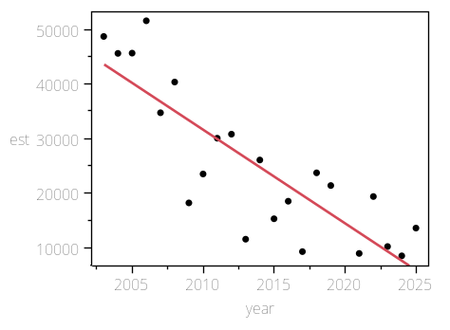

Summary of Fit

RSquare | 0.708489
RSquare Adj | 0.693914
Root Mean Square Error | 7669.591
Mean of Response | 25182.62
Observations (or Sum Wgts) | 22

AICc | 461.2506
BIC | 463.1904

Analysis of Variance

Source | DF | Sum of Squares | Mean Square | F Ratio
Model | 1 | 2859255926 | 2.8593e+9 | 48.6081
Error | 20 | 1176452618 | 58822631 | Prob > F
C. Total | 21 | 4035708544 |  | <.0001*

Parameter Estimates

Term | Estimate | Std Error | t Ratio | Prob>|t| | Lower 95% | Upper 95%
Intercept | 3474765.9 | 494782.9 | 7.02 | <.0001* | 2442666.8 | 4506865
year | -1713.034 | 245.7037 | -6.97 | <.0001* | -2225.563 | -1200.505

coord=index, species=dogfish, area=North of Cape Mendocino

Regression Plot
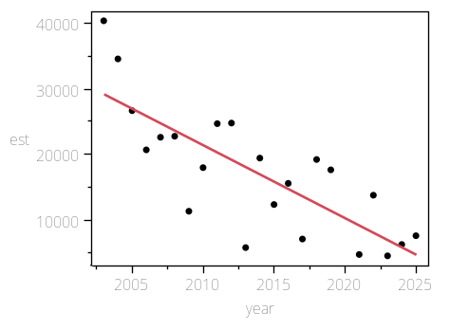

Summary of Fit

RSquare | 0.616706
RSquare Adj | 0.597542
Root Mean Square Error | 6103.065
Mean of Response | 17251.33
Observations (or Sum Wgts) | 22

AICc | 451.1978
BIC | 453.1376

Analysis of Variance

Source | DF | Sum of Squares | Mean Square | F Ratio
Model | 1 | 1198595117 | 1.1986e+9 | 32.1793
Error | 20 | 744948039 | 37247402 | Prob > F
C. Total | 21 | 1943543157 |  | <.0001*

Parameter Estimates

Term | Estimate | Std Error | t Ratio | Prob>|t| | Lower 95% | Upper 95%
Intercept | 2250702 | 393722.7 | 5.72 | <.0001* | 1429410.8 | 3071993.2
year | -1109.113 | 195.5183 | -5.67 | <.0001* | -1516.957 | -701.2687

coord=index, species=dogfish, area=North of Monterey Bay

Regression Plot
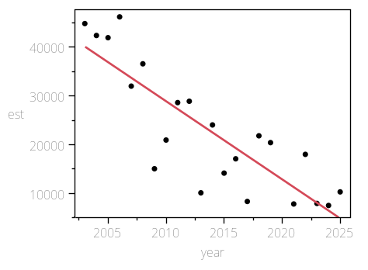

Summary of Fit

RSquare | 0.707637
RSquare Adj | 0.693018
Root Mean Square Error | 7219.935
Mean of Response | 22883.55
Observations (or Sum Wgts) | 22

AICc | 458.5923
BIC | 460.5321

Analysis of Variance

Source | DF | Sum of Squares | Mean Square | F Ratio
Model | 1 | 2523387632 | 2.5234e+9 | 48.4080
Error | 20 | 1042549280 | 52127464 | Prob > F
C. Total | 21 | 3565936912 |  | <.0001*

Parameter Estimates

Term | Estimate | Std Error | t Ratio | Prob>|t| | Lower 95% | Upper 95%
Intercept | 3263533.4 | 465774.6 | 7.01 | <.0001* | 2291944.6 | 4235122.1
year | -1609.279 | 231.2985 | -6.96 | <.0001* | -2091.76 | -1126.799

coord=index, species=dogfish, area=OR

Regression Plot
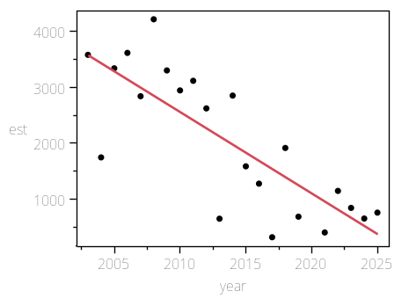

Summary of Fit

RSquare | 0.633365
RSquare Adj | 0.615033
Root Mean Square Error | 770.2768
Mean of Response | 2011.341
Observations (or Sum Wgts) | 22

AICc | 360.1268
BIC | 362.0666

Analysis of Variance

Source | DF | Sum of Squares | Mean Square | F Ratio
Model | 1 | 20499522 | 20499522 | 34.5502
Error | 20 | 11866528 | 593326.41 | Prob > F
C. Total | 21 | 32366050 |  | <.0001*

Parameter Estimates

Term | Estimate | Std Error | t Ratio | Prob>|t| | Lower 95% | Upper 95%
Intercept | 294098.18 | 49692.33 | 5.92 | <.0001* | 190441.8 | 397754.56
year | -145.0479 | 24.67666 | -5.88 | <.0001* | -196.5225 | -93.57326

coord=index, species=dogfish, area=South of Cape Mendocino

Regression Plot
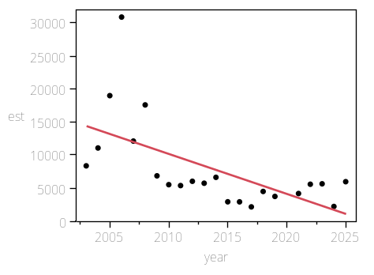

Summary of Fit

RSquare | 0.368106
RSquare Adj | 0.336511
Root Mean Square Error | 5522.833
Mean of Response | 7931.295
Observations (or Sum Wgts) | 22

AICc | 446.8022
BIC | 448.742

Analysis of Variance

Source | DF | Sum of Squares | Mean Square | F Ratio
Model | 1 | 355370690 | 355370690 | 11.6509
Error | 20 | 610033676 | 30501684 | Prob > F
C. Total | 21 | 965404366 |  | 0.0028*

Parameter Estimates

Term | Estimate | Std Error | t Ratio | Prob>|t| | Lower 95% | Upper 95%
Intercept | 1224063.9 | 356290.6 | 3.44 | 0.0026* | 480854.64 | 1967273.1
year | -603.9212 | 176.93 | -3.41 | 0.0028* | -972.9906 | -234.8518

coord=index, species=dogfish, area=South of Monterey Bay

Regression Plot
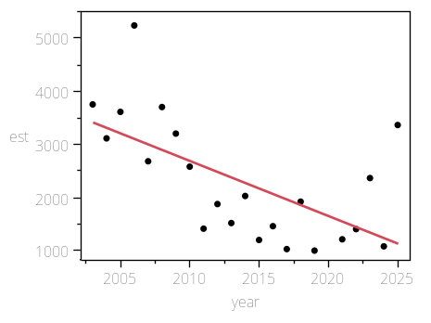

Summary of Fit

RSquare | 0.377891
RSquare Adj | 0.346786
Root Mean Square Error | 929.1862
Mean of Response | 2299.071
Observations (or Sum Wgts) | 22

AICc | 368.3794
BIC | 370.3192

Analysis of Variance

Source | DF | Sum of Squares | Mean Square | F Ratio
Model | 1 | 10489040 | 10489040 | 12.1487
Error | 20 | 17267741 | 863387.04 | Prob > F
C. Total | 21 | 27756781 |  | 0.0023*

Parameter Estimates

Term | Estimate | Std Error | t Ratio | Prob>|t| | Lower 95% | Upper 95%
Intercept | 211232.53 | 59943.94 | 3.52 | 0.0021* | 86191.672 | 336273.39
year | -103.7546 | 29.76749 | -3.49 | 0.0023* | -165.8485 | -41.6607

coord=index, species=dogfish, area=WA

Regression Plot
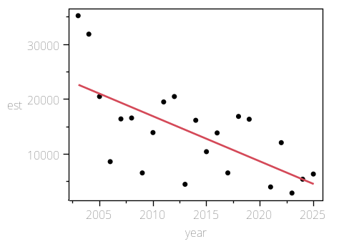

Summary of Fit

RSquare | 0.434422
RSquare Adj | 0.406143
Root Mean Square Error | 6542.196
Mean of Response | 13813.6
Observations (or Sum Wgts) | 22

AICc | 454.255
BIC | 456.1948

Analysis of Variance

Source | DF | Sum of Squares | Mean Square | F Ratio
Model | 1 | 657499857 | 657499857 | 15.3620
Error | 20 | 856006532 | 42800327 | Prob > F
C. Total | 21 | 1513506388 |  | 0.0008*

Parameter Estimates

Term | Estimate | Std Error | t Ratio | Prob>|t| | Lower 95% | Upper 95%
Intercept | 1668013.3 | 422052.1 | 3.95 | 0.0008* | 787628.16 | 2548398.5
year | -821.4617 | 209.5864 | -3.92 | 0.0008* | -1258.651 | -384.2722

coord=index, species=longnose, area=CA

Regression Plot
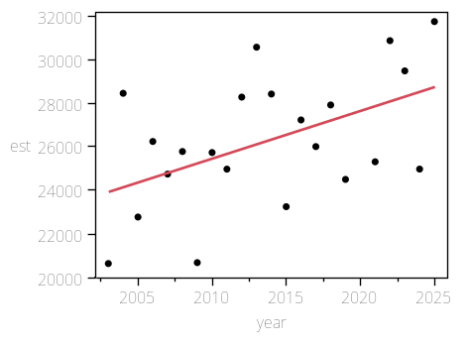

Summary of Fit

RSquare | 0.243776
RSquare Adj | 0.205964
Root Mean Square Error | 2688.788
Mean of Response | 26284.6
Observations (or Sum Wgts) | 22

AICc | 415.131
BIC | 417.0708

Analysis of Variance

Source | DF | Sum of Squares | Mean Square | F Ratio
Model | 1 | 46610380 | 46610380 | 6.4472
Error | 20 | 144591656 | 7229582.8 | Prob > F
C. Total | 21 | 191202036 |  | 0.0195*

Parameter Estimates

Term | Estimate | Std Error | t Ratio | Prob>|t| | Lower 95% | Upper 95%
Intercept | -414150 | 173459.9 | -2.39 | 0.0269* | -775981 | -52318.99
year | 218.71612 | 86.13826 | 2.54 | 0.0195* | 39.03486 | 398.39738

coord=index, species=longnose, area=Coastwide

Regression Plot
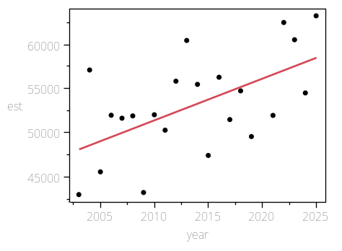

Summary of Fit

RSquare | 0.327109
RSquare Adj | 0.293464
Root Mean Square Error | 4720.585
Mean of Response | 53167.28
Observations (or Sum Wgts) | 22

AICc | 439.8961
BIC | 441.8359

Analysis of Variance

Source | DF | Sum of Squares | Mean Square | F Ratio
Model | 1 | 216655085 | 216655085 | 9.7225
Error | 20 | 445678422 | 22283921 | Prob > F
C. Total | 21 | 662333507 |  | 0.0054*

Parameter Estimates

Term | Estimate | Std Error | t Ratio | Prob>|t| | Lower 95% | Upper 95%
Intercept | -896397.4 | 304535.8 | -2.94 | 0.0080* | -1531648 | -261147
year | 471.54583 | 151.2291 | 3.12 | 0.0054* | 156.08753 | 787.00414

coord=index, species=longnose, area=North of Cape Mendocino

Regression Plot
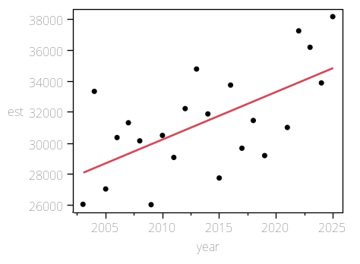

Summary of Fit

RSquare | 0.386697
RSquare Adj | 0.356032
Root Mean Square Error | 2700.078
Mean of Response | 31401.76
Observations (or Sum Wgts) | 22

AICc | 415.3154
BIC | 417.2552

Analysis of Variance

Source | DF | Sum of Squares | Mean Square | F Ratio
Model | 1 | 91934376 | 91934376 | 12.6103
Error | 20 | 145808419 | 7290420.9 | Prob > F
C. Total | 21 | 237742794 |  | 0.0020*

Parameter Estimates

Term | Estimate | Std Error | t Ratio | Prob>|t| | Lower 95% | Upper 95%
Intercept | -587154.3 | 174188.2 | -3.37 | 0.0030* | -950504.6 | -223804.1
year | 307.16974 | 86.49993 | 3.55 | 0.0020* | 126.73404 | 487.60544

coord=index, species=longnose, area=North of Monterey Bay

Regression Plot
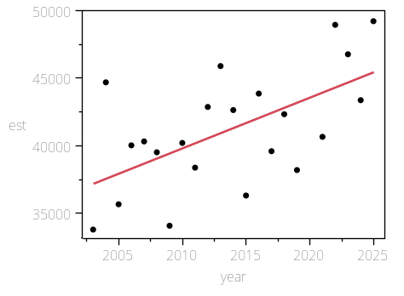

Summary of Fit

RSquare | 0.348794
RSquare Adj | 0.316234
Root Mean Square Error | 3570.805
Mean of Response | 41232.54
Observations (or Sum Wgts) | 22

AICc | 427.6138
BIC | 429.5536

Analysis of Variance

Source | DF | Sum of Squares | Mean Square | F Ratio
Model | 1 | 136588382 | 136588382 | 10.7123
Error | 20 | 255012957 | 12750648 | Prob > F
C. Total | 21 | 391601339 |  | 0.0038*

Parameter Estimates

Term | Estimate | Std Error | t Ratio | Prob>|t| | Lower 95% | Upper 95%
Intercept | -712725.2 | 230360.8 | -3.09 | 0.0057* | -1193249 | -232200.9
year | 374.40906 | 114.3946 | 3.27 | 0.0038* | 135.78607 | 613.03205

coord=index, species=longnose, area=OR

Regression Plot
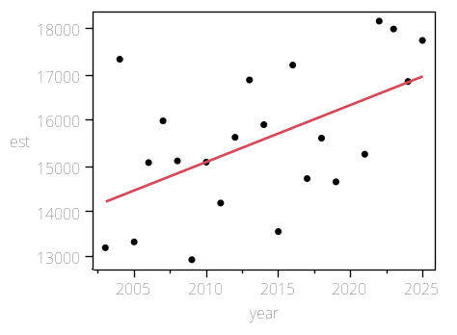

Summary of Fit

RSquare | 0.288021
RSquare Adj | 0.252422
Root Mean Square Error | 1372.411
Mean of Response | 15559.56
Observations (or Sum Wgts) | 22

AICc | 385.5401
BIC | 387.4799

Analysis of Variance

Source | DF | Sum of Squares | Mean Square | F Ratio
Model | 1 | 15238932 | 15238932 | 8.0907
Error | 20 | 37670257 | 1883512.9 | Prob > F
C. Total | 21 | 52909189 |  | 0.0100*

Parameter Estimates

Term | Estimate | Std Error | t Ratio | Prob>|t| | Lower 95% | Upper 95%
Intercept | -236276.2 | 88537.4 | -2.67 | 0.0148* | -420962 | -51590.4
year | 125.05951 | 43.96669 | 2.84 | 0.0100* | 33.346606 | 216.77242

coord=index, species=longnose, area=South of Cape Mendocino

Regression Plot
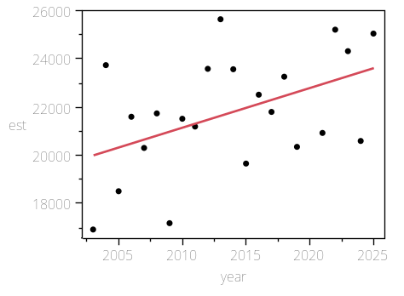

Summary of Fit

RSquare | 0.213256
RSquare Adj | 0.173919
Root Mean Square Error | 2203.687
Mean of Response | 21765.53
Observations (or Sum Wgts) | 22

AICc | 406.3768
BIC | 408.3166

Analysis of Variance

Source | DF | Sum of Squares | Mean Square | F Ratio
Model | 1 | 26326817 | 26326817 | 5.4212
Error | 20 | 97124768 | 4856238.4 | Prob > F
C. Total | 21 | 123451585 |  | 0.0305*

Parameter Estimates

Term | Estimate | Std Error | t Ratio | Prob>|t| | Lower 95% | Upper 95%
Intercept | -309243.1 | 142164.9 | -2.18 | 0.0418* | -605793.9 | -12692.23
year | 164.37609 | 70.59752 | 2.33 | 0.0305* | 17.112236 | 311.63994

coord=index, species=longnose, area=South of Monterey Bay

Regression Plot
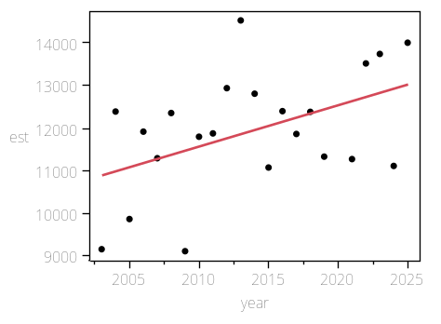

Summary of Fit

RSquare | 0.218295
RSquare Adj | 0.179209
Root Mean Square Error | 1283.008
Mean of Response | 11934.74
Observations (or Sum Wgts) | 22

AICc | 382.5761
BIC | 384.5159

Analysis of Variance

Source | DF | Sum of Squares | Mean Square | F Ratio
Model | 1 | 9193659 | 9193659 | 5.5851
Error | 20 | 32922170 | 1646109 | Prob > F
C. Total | 21 | 42115830 |  | 0.0284*

Parameter Estimates

Term | Estimate | Std Error | t Ratio | Prob>|t| | Lower 95% | Upper 95%
Intercept | -183672.2 | 82769.76 | -2.22 | 0.0382* | -356326.9 | -11017.53
year | 97.136773 | 41.10254 | 2.36 | 0.0284* | 11.39837 | 182.87518

coord=index, species=longnose, area=WA

Regression Plot
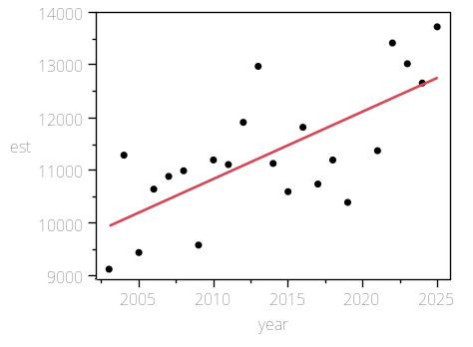

Summary of Fit

RSquare | 0.494725
RSquare Adj | 0.469461
Root Mean Square Error | 901.2751
Mean of Response | 11323.12
Observations (or Sum Wgts) | 22

AICc | 367.0375
BIC | 368.9773

Analysis of Variance

Source | DF | Sum of Squares | Mean Square | F Ratio
Model | 1 | 15906705 | 15906705 | 19.5824
Error | 20 | 16245938 | 812296.89 | Prob > F
C. Total | 21 | 32152643 |  | 0.0003*

Parameter Estimates

Term | Estimate | Std Error | t Ratio | Prob>|t| | Lower 95% | Upper 95%
Intercept | -245971.2 | 58143.33 | -4.23 | 0.0004* | -367256.1 | -124686.4
year | 127.7702 | 28.87333 | 4.43 | 0.0003* | 67.541491 | 187.99891

coord=X, species=big skate, area=CA

Regression Plot
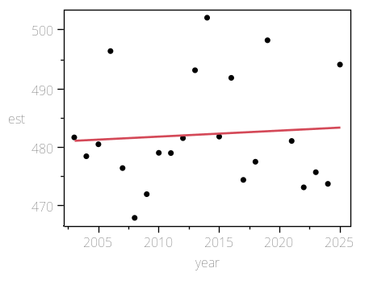

Summary of Fit

RSquare | 0.005471
RSquare Adj | -0.04426
Root Mean Square Error | 9.612974
Mean of Response | 482.2333
Observations (or Sum Wgts) | 22

AICc | 167.2468
BIC | 169.1866

Analysis of Variance

Source | DF | Sum of Squares | Mean Square | F Ratio
Model | 1 | 10.1675 | 10.1675 | 0.1100
Error | 20 | 1848.1855 | 92.4093 | Prob > F
C. Total | 21 | 1858.3530 |  | 0.7436

Parameter Estimates

Term | Estimate | Std Error | t Ratio | Prob>|t| | Lower 95% | Upper 95%
Intercept | 276.52761 | 620.155 | 0.45 | 0.6605 | -1017.093 | 1570.1483
year | 0.1021517 | 0.307962 | 0.33 | 0.7436 | -0.540246 | 0.7445494

coord=X, species=big skate, area=Coastwide

Regression Plot
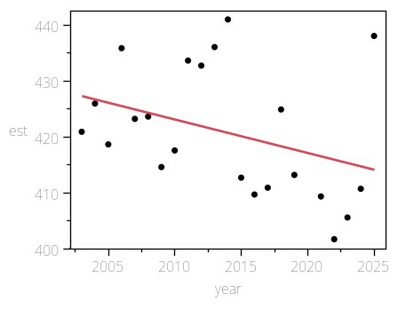

Summary of Fit

RSquare | 0.12673
RSquare Adj | 0.083067
Root Mean Square Error | 10.96842
Mean of Response | 420.8704
Observations (or Sum Wgts) | 22

AICc | 173.0507
BIC | 174.9905

Analysis of Variance

Source | DF | Sum of Squares | Mean Square | F Ratio
Model | 1 | 349.1802 | 349.180 | 2.9024
Error | 20 | 2406.1238 | 120.306 | Prob > F
C. Total | 21 | 2755.3040 |  | 0.1039

Parameter Estimates

Term | Estimate | Std Error | t Ratio | Prob>|t| | Lower 95% | Upper 95%
Intercept | 1626.364 | 707.5978 | 2.30 | 0.0325* | 150.34087 | 3102.3872
year | -0.598638 | 0.351385 | -1.70 | 0.1039 | -1.331615 | 0.1343387

coord=X, species=big skate, area=North of Cape Mendocino

Regression Plot
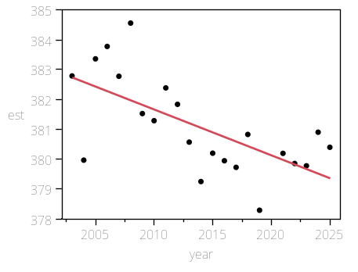

Summary of Fit

RSquare | 0.425345
RSquare Adj | 0.396613
Root Mean Square Error | 1.243404
Mean of Response | 381.088
Observations (or Sum Wgts) | 22

AICc | 77.25531
BIC | 79.19511

Analysis of Variance

Source | DF | Sum of Squares | Mean Square | F Ratio
Model | 1 | 22.887010 | 22.8870 | 14.8035
Error | 20 | 30.921049 | 1.5461 | Prob > F
C. Total | 21 | 53.808059 |  | 0.0010*

Parameter Estimates

Term | Estimate | Std Error | t Ratio | Prob>|t| | Lower 95% | Upper 95%
Intercept | 689.71553 | 80.21482 | 8.60 | <.0001* | 522.39035 | 857.04071
year | -0.153262 | 0.039834 | -3.85 | 0.0010* | -0.236354 | -0.07017

coord=X, species=big skate, area=North of Monterey Bay

Regression Plot
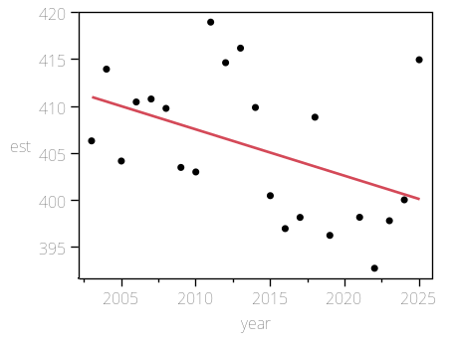

Summary of Fit

RSquare | 0.199334
RSquare Adj | 0.159301
Root Mean Square Error | 6.913598
Mean of Response | 405.6877
Observations (or Sum Wgts) | 22

AICc | 152.7434
BIC | 154.6832

Analysis of Variance

Source | DF | Sum of Squares | Mean Square | F Ratio
Model | 1 | 237.9959 | 237.996 | 4.9792
Error | 20 | 955.9568 | 47.798 | Prob > F
C. Total | 21 | 1193.9527 |  | 0.0373*

Parameter Estimates

Term | Estimate | Std Error | t Ratio | Prob>|t| | Lower 95% | Upper 95%
Intercept | 1400.921 | 446.0121 | 3.14 | 0.0051* | 470.55612 | 2331.2859
year | -0.494224 | 0.221485 | -2.23 | 0.0373* | -0.956233 | -0.032216

coord=X, species=big skate, area=OR

Regression Plot
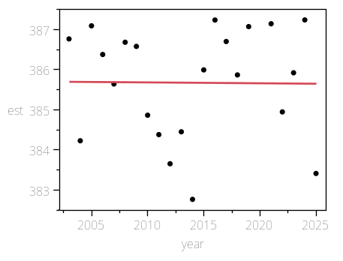

Summary of Fit

RSquare | 0.000112
RSquare Adj | -0.04988
Root Mean Square Error | 1.410924
Mean of Response | 385.673
Observations (or Sum Wgts) | 22

AICc | 82.81657
BIC | 84.75636

Analysis of Variance

Source | DF | Sum of Squares | Mean Square | F Ratio
Model | 1 | 0.004479 | 0.00448 | 0.0023
Error | 20 | 39.814121 | 1.99071 | Prob > F
C. Total | 21 | 39.818600 |  | 0.9626

Parameter Estimates

Term | Estimate | Std Error | t Ratio | Prob>|t| | Lower 95% | Upper 95%
Intercept | 389.99057 | 91.02193 | 4.28 | 0.0004* | 200.12214 | 579.859
year | -0.002144 | 0.0452 | -0.05 | 0.9626 | -0.096431 | 0.0921425

coord=X, species=big skate, area=South of Cape Mendocino

Regression Plot
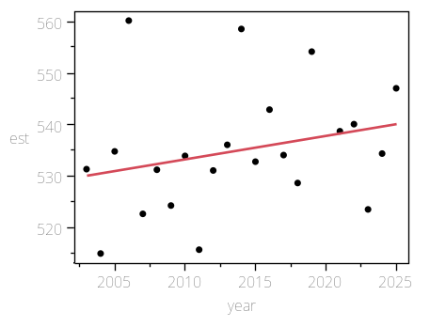

Summary of Fit

RSquare | 0.065824
RSquare Adj | 0.019115
Root Mean Square Error | 11.98038
Mean of Response | 534.9747
Observations (or Sum Wgts) | 22

AICc | 176.9337
BIC | 178.8735

Analysis of Variance

Source | DF | Sum of Squares | Mean Square | F Ratio
Model | 1 | 202.2673 | 202.267 | 1.4092
Error | 20 | 2870.5915 | 143.530 | Prob > F
C. Total | 21 | 3072.8588 |  | 0.2491

Parameter Estimates

Term | Estimate | Std Error | t Ratio | Prob>|t| | Lower 95% | Upper 95%
Intercept | -382.5188 | 772.882 | -0.49 | 0.6260 | -1994.722 | 1229.6848
year | 0.4556195 | 0.383805 | 1.19 | 0.2491 | -0.344983 | 1.2562219

coord=X, species=big skate, area=South of Monterey Bay

Regression Plot
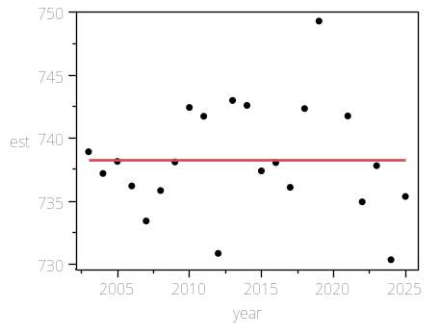

Summary of Fit

RSquare | 2.325e-7
RSquare Adj | -0.05
Root Mean Square Error | 4.460577
Mean of Response | 738.2416
Observations (or Sum Wgts) | 22

AICc | 133.462
BIC | 135.4018

Analysis of Variance

Source | DF | Sum of Squares | Mean Square | F Ratio
Model | 1 | 9.25159e-5 | 9.252e-5 | 0.0000
Error | 20 | 397.93490 | 19.8967 | Prob > F
C. Total | 21 | 397.93499 |  | 0.9983

Parameter Estimates

Term | Estimate | Std Error | t Ratio | Prob>|t| | Lower 95% | Upper 95%
Intercept | 738.86212 | 287.762 | 2.57 | 0.0184* | 138.60102 | 1339.1232
year | -0.000308 | 0.142899 | -0.00 | 0.9983 | -0.298391 | 0.2977748

coord=X, species=big skate, area=WA

Regression Plot
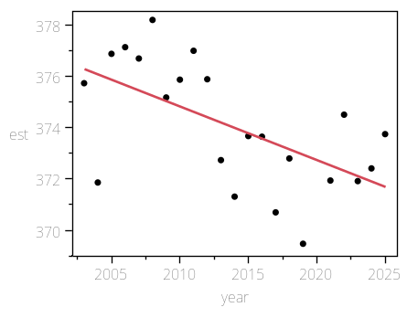

Summary of Fit

RSquare | 0.350155
RSquare Adj | 0.317663
Root Mean Square Error | 1.979343
Mean of Response | 374.0318
Observations (or Sum Wgts) | 22

AICc | 97.71145
BIC | 99.65125

Analysis of Variance

Source | DF | Sum of Squares | Mean Square | F Ratio
Model | 1 | 42.22047 | 42.2205 | 10.7766
Error | 20 | 78.35594 | 3.9178 | Prob > F
C. Total | 21 | 120.57641 |  | 0.0037*

Parameter Estimates

Term | Estimate | Std Error | t Ratio | Prob>|t| | Lower 95% | Upper 95%
Intercept | 793.21282 | 127.6919 | 6.21 | <.0001* | 526.85212 | 1059.5735
year | -0.208162 | 0.06341 | -3.28 | 0.0037* | -0.340434 | -0.07589

coord=X, species=dogfish, area=CA

Regression Plot
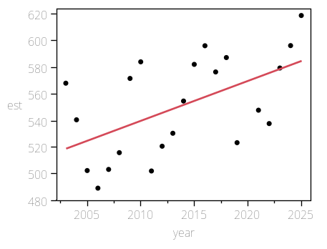

Summary of Fit

RSquare | 0.304193
RSquare Adj | 0.269402
Root Mean Square Error | 31.62293
Mean of Response | 551.0884
Observations (or Sum Wgts) | 22

AICc | 219.6406
BIC | 221.5804

Analysis of Variance

Source | DF | Sum of Squares | Mean Square | F Ratio
Model | 1 | 8743.670 | 8743.67 | 8.7436
Error | 20 | 20000.193 | 1000.01 | Prob > F
C. Total | 21 | 28743.863 |  | 0.0078*

Parameter Estimates

Term | Estimate | Std Error | t Ratio | Prob>|t| | Lower 95% | Upper 95%
Intercept | -5481.268 | 2040.068 | -2.69 | 0.0142* | -9736.775 | -1225.761
year | 2.9956174 | 1.013075 | 2.96 | 0.0078* | 0.8823802 | 5.1088547

coord=X, species=dogfish, area=Coastwide

Regression Plot
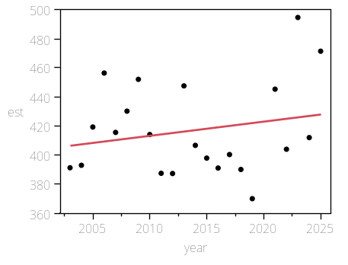

Summary of Fit

RSquare | 0.043728
RSquare Adj | -0.00409
Root Mean Square Error | 31.81906
Mean of Response | 416.9371
Observations (or Sum Wgts) | 22

AICc | 219.9127
BIC | 221.8525

Analysis of Variance

Source | DF | Sum of Squares | Mean Square | F Ratio
Model | 1 | 925.941 | 925.94 | 0.9146
Error | 20 | 20249.047 | 1012.45 | Prob > F
C. Total | 21 | 21174.988 |  | 0.3503

Parameter Estimates

Term | Estimate | Std Error | t Ratio | Prob>|t| | Lower 95% | Upper 95%
Intercept | -1546.115 | 2052.72 | -0.75 | 0.4601 | -5828.014 | 2735.785
year | 0.9748349 | 1.019358 | 0.96 | 0.3503 | -1.151509 | 3.1011786

coord=X, species=dogfish, area=North of Cape Mendocino

Regression Plot
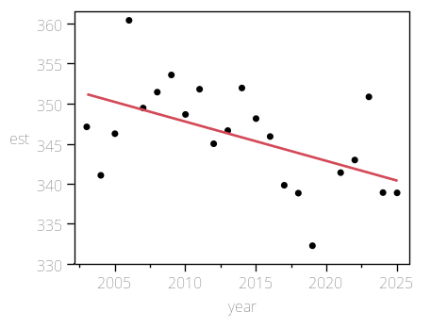

Summary of Fit

RSquare | 0.276643
RSquare Adj | 0.240475
Root Mean Square Error | 5.542803
Mean of Response | 345.9494
Observations (or Sum Wgts) | 22

AICc | 143.0198
BIC | 144.9596

Analysis of Variance

Source | DF | Sum of Squares | Mean Square | F Ratio
Model | 1 | 234.99341 | 234.993 | 7.6489
Error | 20 | 614.45330 | 30.723 | Prob > F
C. Total | 21 | 849.44671 |  | 0.0119*

Parameter Estimates

Term | Estimate | Std Error | t Ratio | Prob>|t| | Lower 95% | Upper 95%
Intercept | 1334.8849 | 357.5789 | 3.73 | 0.0013* | 588.98831 | 2080.7815
year | -0.491097 | 0.17757 | -2.77 | 0.0119* | -0.861501 | -0.120693

coord=X, species=dogfish, area=North of Monterey Bay

Regression Plot
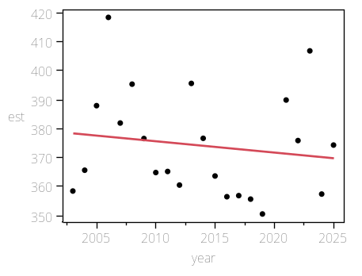

Summary of Fit

RSquare | 0.021146
RSquare Adj | -0.0278
Root Mean Square Error | 18.53306
Mean of Response | 374.1698
Observations (or Sum Wgts) | 22

AICc | 196.1303
BIC | 198.0701

Analysis of Variance

Source | DF | Sum of Squares | Mean Square | F Ratio
Model | 1 | 148.3967 | 148.397 | 0.4320
Error | 20 | 6869.4842 | 343.474 | Prob > F
C. Total | 21 | 7017.8809 |  | 0.5185

Parameter Estimates

Term | Estimate | Std Error | t Ratio | Prob>|t| | Lower 95% | Upper 95%
Intercept | 1160.0426 | 1195.61 | 0.97 | 0.3435 | -1333.956 | 3654.0415
year | -0.390258 | 0.593727 | -0.66 | 0.5185 | -1.62875 | 0.8482343

coord=X, species=dogfish, area=OR

Regression Plot
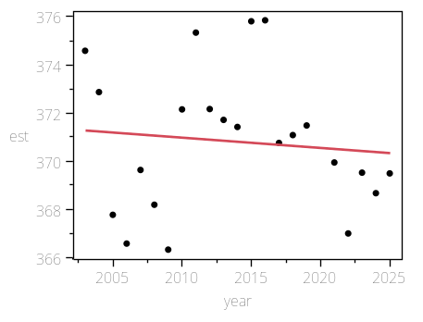

Summary of Fit

RSquare | 0.010229
RSquare Adj | -0.03926
Root Mean Square Error | 2.926951
Mean of Response | 370.8228
Observations (or Sum Wgts) | 22

AICc | 114.9241
BIC | 116.8639

Analysis of Variance

Source | DF | Sum of Squares | Mean Square | F Ratio
Model | 1 | 1.77074 | 1.77074 | 0.2067
Error | 20 | 171.34088 | 8.56704 | Prob > F
C. Total | 21 | 173.11162 |  | 0.6543

Parameter Estimates

Term | Estimate | Std Error | t Ratio | Prob>|t| | Lower 95% | Upper 95%
Intercept | 456.66831 | 188.8243 | 2.42 | 0.0252* | 62.787631 | 850.54899
year | -0.04263 | 0.093768 | -0.45 | 0.6543 | -0.238227 | 0.1529666

coord=X, species=dogfish, area=South of Cape Mendocino

Regression Plot
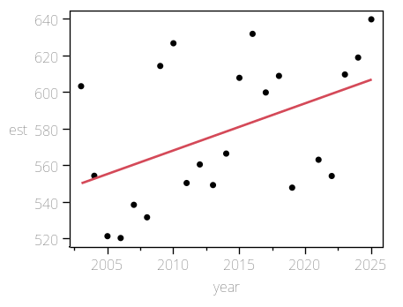

Summary of Fit

RSquare | 0.211595
RSquare Adj | 0.172175
Root Mean Square Error | 34.77398
Mean of Response | 578.0732
Observations (or Sum Wgts) | 22

AICc | 223.8201
BIC | 225.7598

Analysis of Variance

Source | DF | Sum of Squares | Mean Square | F Ratio
Model | 1 | 6490.754 | 6490.75 | 5.3677
Error | 20 | 24184.589 | 1209.23 | Prob > F
C. Total | 21 | 30675.343 |  | 0.0312*

Parameter Estimates

Term | Estimate | Std Error | t Ratio | Prob>|t| | Lower 95% | Upper 95%
Intercept | -4619.345 | 2243.349 | -2.06 | 0.0527 | -9298.889 | 60.198856
year | 2.5809942 | 1.114022 | 2.32 | 0.0312* | 0.2571847 | 4.9048037

coord=X, species=dogfish, area=South of Monterey Bay

Regression Plot
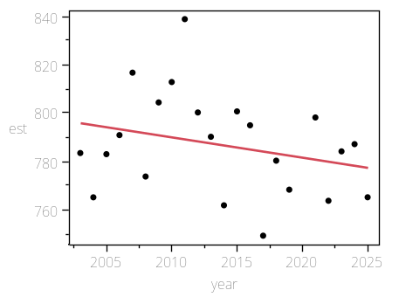

Summary of Fit

RSquare | 0.074036
RSquare Adj | 0.027738
Root Mean Square Error | 20.73686
Mean of Response | 786.8261
Observations (or Sum Wgts) | 22

AICc | 201.074
BIC | 203.0138

Analysis of Variance

Source | DF | Sum of Squares | Mean Square | F Ratio
Model | 1 | 687.6460 | 687.646 | 1.5991
Error | 20 | 8600.3514 | 430.018 | Prob > F
C. Total | 21 | 9287.9974 |  | 0.2206

Parameter Estimates

Term | Estimate | Std Error | t Ratio | Prob>|t| | Lower 95% | Upper 95%
Intercept | 2478.5231 | 1337.783 | 1.85 | 0.0787 | -312.0428 | 5269.0891
year | -0.840082 | 0.664328 | -1.26 | 0.2206 | -2.225846 | 0.5456815

coord=X, species=dogfish, area=WA

Regression Plot
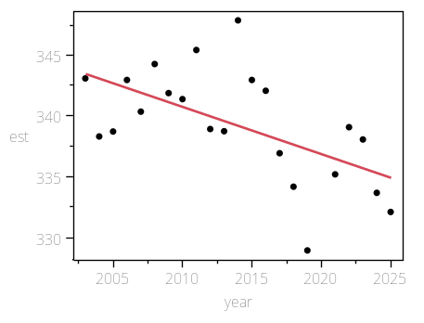

Summary of Fit

RSquare | 0.334571
RSquare Adj | 0.3013
Root Mean Square Error | 3.826597
Mean of Response | 339.28
Observations (or Sum Wgts) | 22

AICc | 126.7167
BIC | 128.6565

Analysis of Variance

Source | DF | Sum of Squares | Mean Square | F Ratio
Model | 1 | 147.24576 | 147.246 | 10.0558
Error | 20 | 292.85682 | 14.643 | Prob > F
C. Total | 21 | 440.10258 |  | 0.0048*

Parameter Estimates

Term | Estimate | Std Error | t Ratio | Prob>|t| | Lower 95% | Upper 95%
Intercept | 1122.0993 | 246.8625 | 4.55 | 0.0002* | 607.15313 | 1637.0455
year | -0.388741 | 0.122589 | -3.17 | 0.0048* | -0.644458 | -0.133025

coord=X, species=longnose, area=CA

Regression Plot
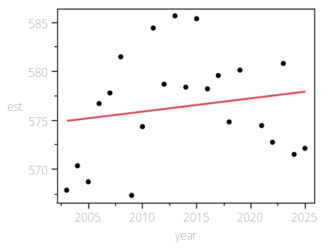

Summary of Fit

RSquare | 0.028534
RSquare Adj | -0.02004
Root Mean Square Error | 5.54118
Mean of Response | 576.4098
Observations (or Sum Wgts) | 22

AICc | 143.0069
BIC | 144.9467

Analysis of Variance

Source | DF | Sum of Squares | Mean Square | F Ratio
Model | 1 | 18.03692 | 18.0369 | 0.5874
Error | 20 | 614.09341 | 30.7047 | Prob > F
C. Total | 21 | 632.13033 |  | 0.4524

Parameter Estimates

Term | Estimate | Std Error | t Ratio | Prob>|t| | Lower 95% | Upper 95%
Intercept | 302.42829 | 357.4742 | 0.85 | 0.4076 | -443.2498 | 1048.1064
year | 0.1360569 | 0.177518 | 0.77 | 0.4524 | -0.234239 | 0.5063524

coord=X, species=longnose, area=Coastwide

Regression Plot
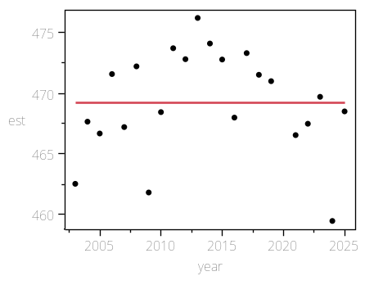

Summary of Fit

RSquare | 2.513e-7
RSquare Adj | -0.05
Root Mean Square Error | 4.357461
Mean of Response | 469.1995
Observations (or Sum Wgts) | 22

AICc | 132.4329
BIC | 134.3727

Analysis of Variance

Source | DF | Sum of Squares | Mean Square | F Ratio
Model | 1 | 9.5427e-5 | 9.543e-5 | 0.0000
Error | 20 | 379.74940 | 18.9875 | Prob > F
C. Total | 21 | 379.74950 |  | 0.9982

Parameter Estimates

Term | Estimate | Std Error | t Ratio | Prob>|t| | Lower 95% | Upper 95%
Intercept | 469.82974 | 281.1098 | 1.67 | 0.1102 | -116.5551 | 1056.2146
year | -0.000313 | 0.139596 | -0.00 | 0.9982 | -0.291505 | 0.2908792

coord=X, species=longnose, area=North of Cape Mendocino

Regression Plot
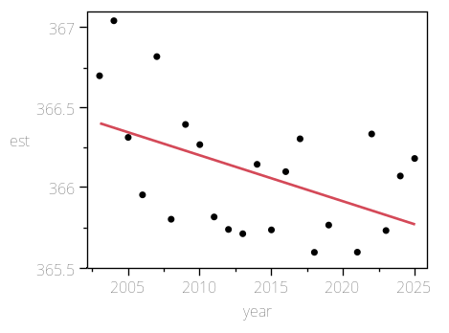

Summary of Fit

RSquare | 0.237199
RSquare Adj | 0.199059
Root Mean Square Error | 0.359368
Mean of Response | 366.0965
Observations (or Sum Wgts) | 22

AICc | 22.63979
BIC | 24.57958

Analysis of Variance

Source | DF | Sum of Squares | Mean Square | F Ratio
Model | 1 | 0.8031739 | 0.803174 | 6.2192
Error | 20 | 2.5829015 | 0.129145 | Prob > F
C. Total | 21 | 3.3860755 |  | 0.0215*

Parameter Estimates

Term | Estimate | Std Error | t Ratio | Prob>|t| | Lower 95% | Upper 95%
Intercept | 423.9121 | 23.18363 | 18.28 | <.0001* | 375.55189 | 472.2723
year | -0.028711 | 0.011513 | -2.49 | 0.0215* | -0.052726 | -0.004696

coord=X, species=longnose, area=North of Monterey Bay

Regression Plot
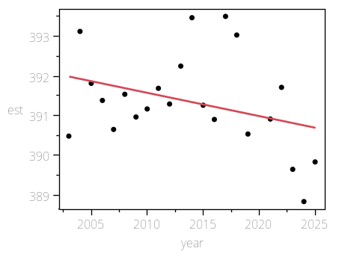

Summary of Fit

RSquare | 0.11027
RSquare Adj | 0.065784
Root Mean Square Error | 1.15598
Mean of Response | 391.3563
Observations (or Sum Wgts) | 22

AICc | 74.04755
BIC | 75.98734

Analysis of Variance

Source | DF | Sum of Squares | Mean Square | F Ratio
Model | 1 | 3.312306 | 3.31231 | 2.4787
Error | 20 | 26.725808 | 1.33629 | Prob > F
C. Total | 21 | 30.038114 |  | 0.1311

Parameter Estimates

Term | Estimate | Std Error | t Ratio | Prob>|t| | Lower 95% | Upper 95%
Intercept | 508.7664 | 74.57494 | 6.82 | <.0001* | 353.2058 | 664.327
year | -0.058305 | 0.037033 | -1.57 | 0.1311 | -0.135555 | 0.0189448

coord=X, species=longnose, area=OR

Regression Plot
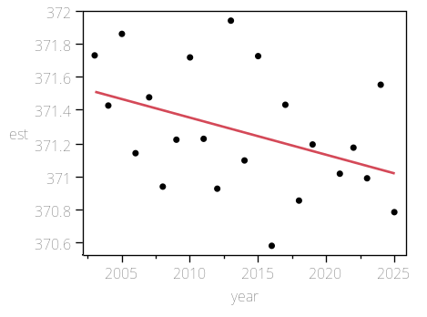

Summary of Fit

RSquare | 0.167887
RSquare Adj | 0.126281
Root Mean Square Error | 0.348686
Mean of Response | 371.2733
Observations (or Sum Wgts) | 22

AICc | 21.31218
BIC | 23.25198

Analysis of Variance

Source | DF | Sum of Squares | Mean Square | F Ratio
Model | 1 | 0.4906077 | 0.490608 | 4.0352
Error | 20 | 2.4316440 | 0.121582 | Prob > F
C. Total | 21 | 2.9222517 |  | 0.0583

Parameter Estimates

Term | Estimate | Std Error | t Ratio | Prob>|t| | Lower 95% | Upper 95%
Intercept | 416.45965 | 22.49456 | 18.51 | <.0001* | 369.53682 | 463.38248
year | -0.022439 | 0.011171 | -2.01 | 0.0583 | -0.045741 | 0.0008622

coord=X, species=longnose, area=South of Cape Mendocino

Regression Plot
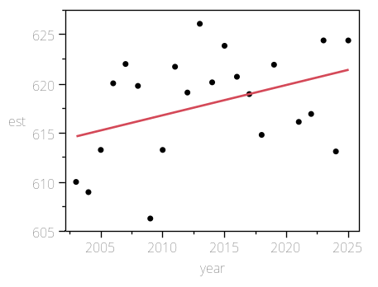

Summary of Fit

RSquare | 0.15029
RSquare Adj | 0.107804
Root Mean Square Error | 5.12052
Mean of Response | 617.9693
Observations (or Sum Wgts) | 22

AICc | 139.5331
BIC | 141.4729

Analysis of Variance

Source | DF | Sum of Squares | Mean Square | F Ratio
Model | 1 | 92.75063 | 92.7506 | 3.5374
Error | 20 | 524.39457 | 26.2197 | Prob > F
C. Total | 21 | 617.14520 |  | 0.0746

Parameter Estimates

Term | Estimate | Std Error | t Ratio | Prob>|t| | Lower 95% | Upper 95%
Intercept | -3.326754 | 330.3365 | -0.01 | 0.9921 | -692.3967 | 685.74314
year | 0.3085304 | 0.164041 | 1.88 | 0.0746 | -0.033654 | 0.6507148

coord=X, species=longnose, area=South of Monterey Bay

Regression Plot
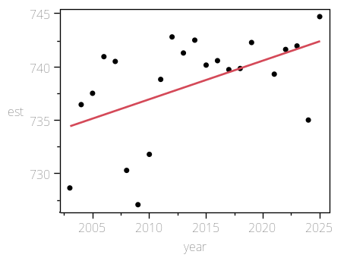

Summary of Fit

RSquare | 0.258382
RSquare Adj | 0.221301
Root Mean Square Error | 4.302288
Mean of Response | 738.3458
Observations (or Sum Wgts) | 22

AICc | 131.8723
BIC | 133.8121

Analysis of Variance

Source | DF | Sum of Squares | Mean Square | F Ratio
Model | 1 | 128.97655 | 128.977 | 6.9681
Error | 20 | 370.19361 | 18.510 | Prob > F
C. Total | 21 | 499.17017 |  | 0.0157*

Parameter Estimates

Term | Estimate | Std Error | t Ratio | Prob>|t| | Lower 95% | Upper 95%
Intercept | 5.6975275 | 277.5505 | 0.02 | 0.9838 | -573.2626 | 584.65764
year | 0.3638269 | 0.137828 | 2.64 | 0.0157* | 0.0763218 | 0.6513321

coord=X, species=longnose, area=WA

Regression Plot
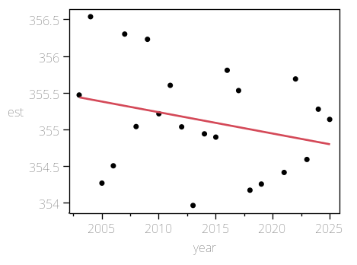

Summary of Fit

RSquare | 0.075248
RSquare Adj | 0.02901
Root Mean Square Error | 0.711184
Mean of Response | 355.1348
Observations (or Sum Wgts) | 22

AICc | 52.67353
BIC | 54.61333

Analysis of Variance

Source | DF | Sum of Squares | Mean Square | F Ratio
Model | 1 | 0.823121 | 0.823121 | 1.6274
Error | 20 | 10.115648 | 0.505782 | Prob > F
C. Total | 21 | 10.938769 |  | 0.2167

Parameter Estimates

Term | Estimate | Std Error | t Ratio | Prob>|t| | Lower 95% | Upper 95%
Intercept | 413.66397 | 45.8801 | 9.02 | <.0001* | 317.95976 | 509.36817
year | -0.029065 | 0.022784 | -1.28 | 0.2167 | -0.076591 | 0.0184606

coord=Y, species=big skate, area=CA

Regression Plot
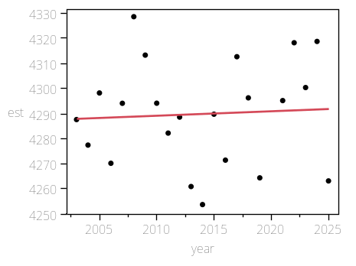

Summary of Fit

RSquare | 0.003448
RSquare Adj | -0.04638
Root Mean Square Error | 21.09122
Mean of Response | 4289.874
Observations (or Sum Wgts) | 22

AICc | 201.8195
BIC | 203.7593

Analysis of Variance

Source | DF | Sum of Squares | Mean Square | F Ratio
Model | 1 | 30.7838 | 30.784 | 0.0692
Error | 20 | 8896.7891 | 444.839 | Prob > F
C. Total | 21 | 8927.5729 |  | 0.7952

Parameter Estimates

Term | Estimate | Std Error | t Ratio | Prob>|t| | Lower 95% | Upper 95%
Intercept | 3931.9414 | 1360.643 | 2.89 | 0.0091* | 1093.6902 | 6770.1926
year | 0.1777462 | 0.67568 | 0.26 | 0.7952 | -1.231698 | 1.5871901

coord=Y, species=big skate, area=Coastwide

Regression Plot
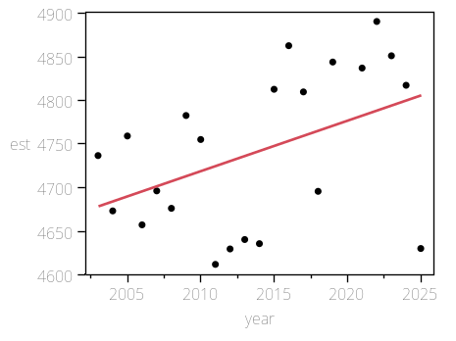

Summary of Fit

RSquare | 0.192474
RSquare Adj | 0.152098
Root Mean Square Error | 83.03326
Mean of Response | 4740.584
Observations (or Sum Wgts) | 22

AICc | 262.1164
BIC | 264.0562

Analysis of Variance

Source | DF | Sum of Squares | Mean Square | F Ratio
Model | 1 | 32866.26 | 32866.3 | 4.7670
Error | 20 | 137890.45 | 6894.5 | Prob > F
C. Total | 21 | 170756.71 |  | 0.0411*

Parameter Estimates

Term | Estimate | Std Error | t Ratio | Prob>|t| | Lower 95% | Upper 95%
Intercept | -6954.821 | 5356.666 | -1.30 | 0.2089 | -18128.63 | 4218.989
year | 5.8078395 | 2.660061 | 2.18 | 0.0411* | 0.2590499 | 11.356629

coord=Y, species=big skate, area=North of Cape Mendocino

Regression Plot
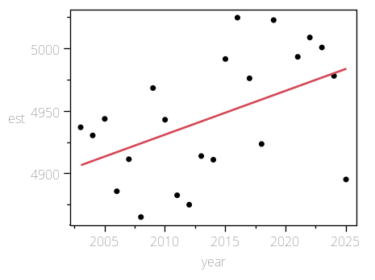

Summary of Fit

RSquare | 0.231284
RSquare Adj | 0.192849
Root Mean Square Error | 44.60838
Mean of Response | 4944.443
Observations (or Sum Wgts) | 22

AICc | 234.7784
BIC | 236.7182

Analysis of Variance

Source | DF | Sum of Squares | Mean Square | F Ratio
Model | 1 | 11974.110 | 11974.1 | 6.0174
Error | 20 | 39798.144 | 1989.9 | Prob > F
C. Total | 21 | 51772.254 |  | 0.0235*

Parameter Estimates

Term | Estimate | Std Error | t Ratio | Prob>|t| | Lower 95% | Upper 95%
Intercept | -2114.859 | 2877.789 | -0.73 | 0.4709 | -8117.821 | 3888.1032
year | 3.5055897 | 1.429078 | 2.45 | 0.0235* | 0.5245856 | 6.4865938

coord=Y, species=big skate, area=North of Monterey Bay

Regression Plot
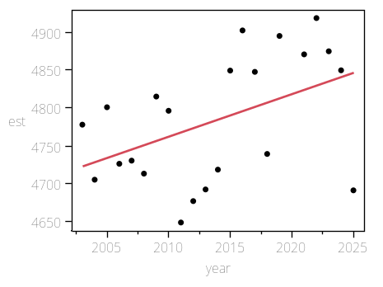

Summary of Fit

RSquare | 0.212572
RSquare Adj | 0.1732
Root Mean Square Error | 75.73321
Mean of Response | 4783.124
Observations (or Sum Wgts) | 22

AICc | 258.0673
BIC | 260.0071

Analysis of Variance

Source | DF | Sum of Squares | Mean Square | F Ratio
Model | 1 | 30966.84 | 30966.8 | 5.3991
Error | 20 | 114710.38 | 5735.5 | Prob > F
C. Total | 21 | 145677.22 |  | 0.0308*

Parameter Estimates

Term | Estimate | Std Error | t Ratio | Prob>|t| | Lower 95% | Upper 95%
Intercept | -6569.299 | 4885.723 | -1.34 | 0.1938 | -16760.74 | 3622.1407
year | 5.6375179 | 2.426196 | 2.32 | 0.0308* | 0.5765623 | 10.698473

coord=Y, species=big skate, area=OR

Regression Plot
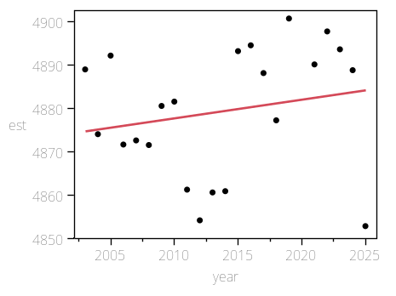

Summary of Fit

RSquare | 0.039896
RSquare Adj | -0.00811
Root Mean Square Error | 14.79181
Mean of Response | 4879.411
Observations (or Sum Wgts) | 22

AICc | 186.209
BIC | 188.1488

Analysis of Variance

Source | DF | Sum of Squares | Mean Square | F Ratio
Model | 1 | 181.8392 | 181.839 | 0.8311
Error | 20 | 4375.9520 | 218.798 | Prob > F
C. Total | 21 | 4557.7913 |  | 0.3728

Parameter Estimates

Term | Estimate | Std Error | t Ratio | Prob>|t| | Lower 95% | Upper 95%
Intercept | 4009.4813 | 954.2535 | 4.20 | 0.0004* | 2018.9434 | 6000.0193
year | 0.4319995 | 0.473872 | 0.91 | 0.3728 | -0.556479 | 1.4204785

coord=Y, species=big skate, area=South of Cape Mendocino

Regression Plot
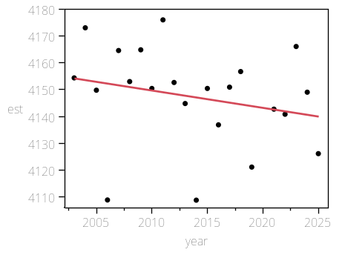

Summary of Fit

RSquare | 0.05848
RSquare Adj | 0.011404
Root Mean Square Error | 18.14816
Mean of Response | 4147.187
Observations (or Sum Wgts) | 22

AICc | 195.2068
BIC | 197.1466

Analysis of Variance

Source | DF | Sum of Squares | Mean Square | F Ratio
Model | 1 | 409.1385 | 409.138 | 1.2422
Error | 20 | 6587.1106 | 329.356 | Prob > F
C. Total | 21 | 6996.2491 |  | 0.2783

Parameter Estimates

Term | Estimate | Std Error | t Ratio | Prob>|t| | Lower 95% | Upper 95%
Intercept | 5452.0812 | 1170.779 | 4.66 | 0.0002* | 3009.8787 | 7894.2836
year | -0.647999 | 0.581396 | -1.11 | 0.2783 | -1.86077 | 0.5647711

coord=Y, species=big skate, area=South of Monterey Bay

Regression Plot
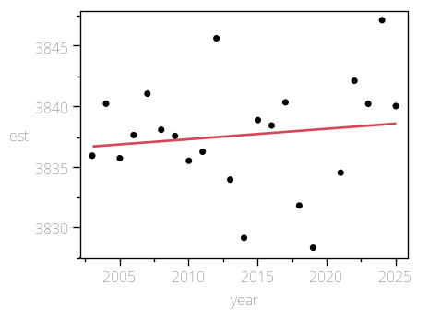

Summary of Fit

RSquare | 0.016344
RSquare Adj | -0.03284
Root Mean Square Error | 4.670793
Mean of Response | 3837.684
Observations (or Sum Wgts) | 22

AICc | 135.4883
BIC | 137.4281

Analysis of Variance

Source | DF | Sum of Squares | Mean Square | F Ratio
Model | 1 | 7.24982 | 7.2498 | 0.3323
Error | 20 | 436.32622 | 21.8163 | Prob > F
C. Total | 21 | 443.57604 |  | 0.5707

Parameter Estimates

Term | Estimate | Std Error | t Ratio | Prob>|t| | Lower 95% | Upper 95%
Intercept | 3663.9826 | 301.3236 | 12.16 | <.0001* | 3035.4326 | 4292.5326
year | 0.0862587 | 0.149634 | 0.58 | 0.5707 | -0.225872 | 0.3983897

coord=Y, species=big skate, area=WA

Regression Plot
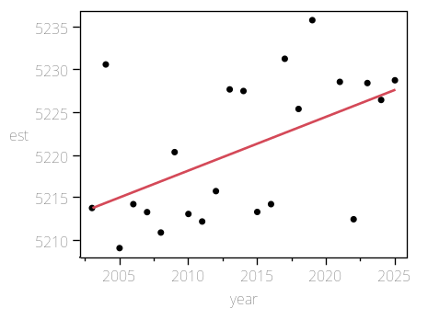

Summary of Fit

RSquare | 0.263843
RSquare Adj | 0.227035
Root Mean Square Error | 7.368536
Mean of Response | 5220.555
Observations (or Sum Wgts) | 22

AICc | 155.5474
BIC | 157.4872

Analysis of Variance

Source | DF | Sum of Squares | Mean Square | F Ratio
Model | 1 | 389.1959 | 389.196 | 7.1681
Error | 20 | 1085.9065 | 54.295 | Prob > F
C. Total | 21 | 1475.1024 |  | 0.0145*

Parameter Estimates

Term | Estimate | Std Error | t Ratio | Prob>|t| | Lower 95% | Upper 95%
Intercept | 3947.8598 | 475.3612 | 8.30 | <.0001* | 2956.2738 | 4939.4458
year | 0.6320095 | 0.236059 | 2.68 | 0.0145* | 0.1395989 | 1.1244201

coord=Y, species=dogfish, area=CA

Regression Plot
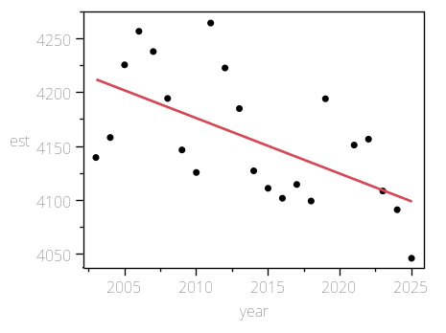

Summary of Fit

RSquare | 0.357898
RSquare Adj | 0.325793
Root Mean Square Error | 48.15038
Mean of Response | 4157.09
Observations (or Sum Wgts) | 22

AICc | 238.1403
BIC | 240.0801

Analysis of Variance

Source | DF | Sum of Squares | Mean Square | F Ratio
Model | 1 | 25845.541 | 25845.5 | 11.1477
Error | 20 | 46369.185 | 2318.5 | Prob > F
C. Total | 21 | 72214.726 |  | 0.0033*

Parameter Estimates

Term | Estimate | Std Error | t Ratio | Prob>|t| | Lower 95% | Upper 95%
Intercept | 14528.383 | 3106.292 | 4.68 | 0.0001* | 8048.7725 | 21007.994
year | -5.150297 | 1.54255 | -3.34 | 0.0033* | -8.368 | -1.932595

coord=Y, species=dogfish, area=Coastwide

Regression Plot
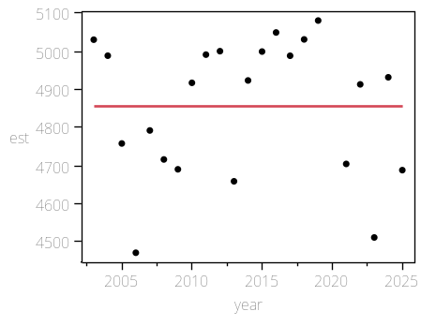

Summary of Fit

RSquare | 3.129e-6
RSquare Adj | -0.05
Root Mean Square Error | 184.8894
Mean of Response | 4854.939
Observations (or Sum Wgts) | 22

AICc | 297.3392
BIC | 299.279

Analysis of Variance

Source | DF | Sum of Squares | Mean Square | F Ratio
Model | 1 | 2.14 | 2.1 | 0.0001
Error | 20 | 683682.12 | 34184.1 | Prob > F
C. Total | 21 | 683684.26 |  | 0.9938

Parameter Estimates

Term | Estimate | Std Error | t Ratio | Prob>|t| | Lower 95% | Upper 95%
Intercept | 4760.5876 | 11927.64 | 0.40 | 0.6940 | -20120.04 | 29641.213
year | 0.0468541 | 5.923134 | 0.01 | 0.9938 | -12.30859 | 12.402296

coord=Y, species=dogfish, area=North of Cape Mendocino

Regression Plot
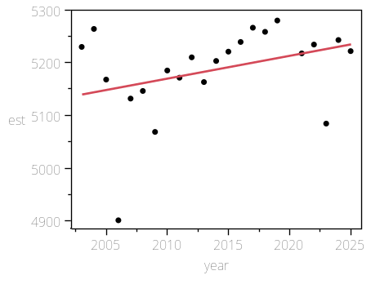

Summary of Fit

RSquare | 0.119554
RSquare Adj | 0.075532
Root Mean Square Error | 81.96871
Mean of Response | 5186.339
Observations (or Sum Wgts) | 22

AICc | 261.5487
BIC | 263.4885

Analysis of Variance

Source | DF | Sum of Squares | Mean Square | F Ratio
Model | 1 | 18246.84 | 18246.8 | 2.7158
Error | 20 | 134377.40 | 6718.9 | Prob > F
C. Total | 21 | 152624.24 |  | 0.1150

Parameter Estimates

Term | Estimate | Std Error | t Ratio | Prob>|t| | Lower 95% | Upper 95%
Intercept | -3527.991 | 5287.99 | -0.67 | 0.5123 | -14558.54 | 7502.5626
year | 4.3274629 | 2.625957 | 1.65 | 0.1150 | -1.150187 | 9.8051128

coord=Y, species=dogfish, area=North of Monterey Bay

Regression Plot
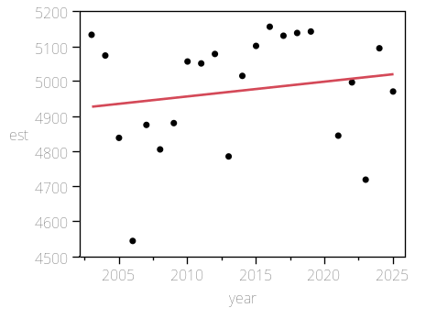

Summary of Fit

RSquare | 0.030373
RSquare Adj | -0.01811
Root Mean Square Error | 166.2636
Mean of Response | 4973.625
Observations (or Sum Wgts) | 22

AICc | 292.6671
BIC | 294.6069

Analysis of Variance

Source | DF | Sum of Squares | Mean Square | F Ratio
Model | 1 | 17318.31 | 17318.3 | 0.6265
Error | 20 | 552872.02 | 27643.6 | Prob > F
C. Total | 21 | 570190.33 |  | 0.4379

Parameter Estimates

Term | Estimate | Std Error | t Ratio | Prob>|t| | Lower 95% | Upper 95%
Intercept | -3516.086 | 10726.05 | -0.33 | 0.7465 | -25890.23 | 18858.061
year | 4.2159188 | 5.326437 | 0.79 | 0.4379 | -6.894834 | 15.326671

coord=Y, species=dogfish, area=OR

Regression Plot
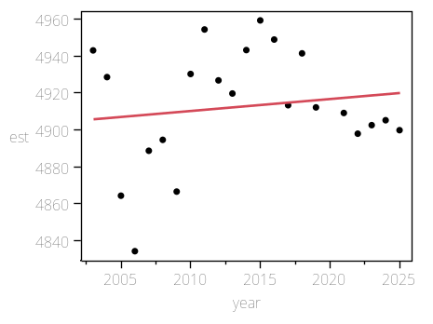

Summary of Fit

RSquare | 0.019661
RSquare Adj | -0.02936
Root Mean Square Error | 31.89686
Mean of Response | 4912.83
Observations (or Sum Wgts) | 22

AICc | 220.0201
BIC | 221.9599

Analysis of Variance

Source | DF | Sum of Squares | Mean Square | F Ratio
Model | 1 | 408.085 | 408.09 | 0.4011
Error | 20 | 20348.187 | 1017.41 | Prob > F
C. Total | 21 | 20756.273 |  | 0.5337

Parameter Estimates

Term | Estimate | Std Error | t Ratio | Prob>|t| | Lower 95% | Upper 95%
Intercept | 3609.6163 | 2057.739 | 1.75 | 0.0947 | -682.7527 | 7901.9853
year | 0.6471648 | 1.02185 | 0.63 | 0.5337 | -1.484378 | 2.7787075

coord=Y, species=dogfish, area=South of Cape Mendocino

Regression Plot
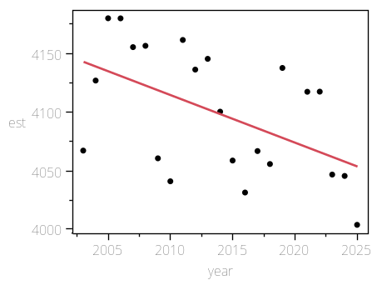

Summary of Fit

RSquare | 0.269183
RSquare Adj | 0.232643
Root Mean Square Error | 46.71875
Mean of Response | 4099.334
Observations (or Sum Wgts) | 22

AICc | 236.8122
BIC | 238.752

Analysis of Variance

Source | DF | Sum of Squares | Mean Square | F Ratio
Model | 1 | 16078.751 | 16078.8 | 7.3666
Error | 20 | 43652.840 | 2182.6 | Prob > F
C. Total | 21 | 59731.591 |  | 0.0134*

Parameter Estimates

Term | Estimate | Std Error | t Ratio | Prob>|t| | Lower 95% | Upper 95%
Intercept | 12279.578 | 3013.934 | 4.07 | 0.0006* | 5992.6222 | 18566.535
year | -4.06224 | 1.496686 | -2.71 | 0.0134* | -7.184273 | -0.940208

coord=Y, species=dogfish, area=South of Monterey Bay

Regression Plot
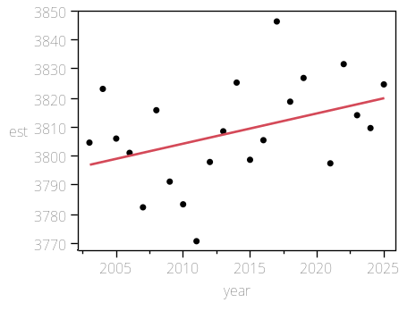

Summary of Fit

RSquare | 0.157798
RSquare Adj | 0.115687
Root Mean Square Error | 16.84322
Mean of Response | 3808.228
Observations (or Sum Wgts) | 22

AICc | 191.9235
BIC | 193.8633

Analysis of Variance

Source | DF | Sum of Squares | Mean Square | F Ratio
Model | 1 | 1063.0755 | 1063.08 | 3.7473
Error | 20 | 5673.8825 | 283.69 | Prob > F
C. Total | 21 | 6736.9580 |  | 0.0672

Parameter Estimates

Term | Estimate | Std Error | t Ratio | Prob>|t| | Lower 95% | Upper 95%
Intercept | 1704.8267 | 1086.595 | 1.57 | 0.1323 | -561.7705 | 3971.4239
year | 1.0445315 | 0.539591 | 1.94 | 0.0672 | -0.081035 | 2.1700984

coord=Y, species=dogfish, area=WA

Regression Plot
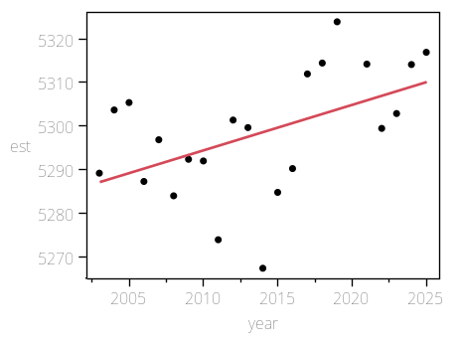

Summary of Fit

RSquare | 0.243979
RSquare Adj | 0.206178
Root Mean Square Error | 12.81896
Mean of Response | 5298.299
Observations (or Sum Wgts) | 22

AICc | 179.9105
BIC | 181.8503

Analysis of Variance

Source | DF | Sum of Squares | Mean Square | F Ratio
Model | 1 | 1060.6044 | 1060.60 | 6.4543
Error | 20 | 3286.5153 | 164.33 | Prob > F
C. Total | 21 | 4347.1197 |  | 0.0195*

Parameter Estimates

Term | Estimate | Std Error | t Ratio | Prob>|t| | Lower 95% | Upper 95%
Intercept | 3197.3433 | 826.9806 | 3.87 | 0.0010* | 1472.292 | 4922.3947
year | 1.0433167 | 0.410669 | 2.54 | 0.0195* | 0.1866755 | 1.899958

coord=Y, species=longnose, area=CA

Regression Plot
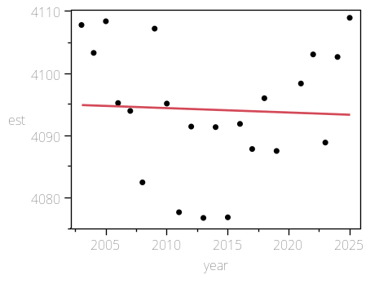

Summary of Fit

RSquare | 0.002241
RSquare Adj | -0.04765
Root Mean Square Error | 10.44811
Mean of Response | 4094.169
Observations (or Sum Wgts) | 22

AICc | 170.9123
BIC | 172.8521

Analysis of Variance

Source | DF | Sum of Squares | Mean Square | F Ratio
Model | 1 | 4.9046 | 4.905 | 0.0449
Error | 20 | 2183.2582 | 109.163 | Prob > F
C. Total | 21 | 2188.1628 |  | 0.8343

Parameter Estimates

Term | Estimate | Std Error | t Ratio | Prob>|t| | Lower 95% | Upper 95%
Intercept | 4237.0388 | 674.0313 | 6.29 | <.0001* | 2831.0342 | 5643.0434
year | -0.070948 | 0.334716 | -0.21 | 0.8343 | -0.769154 | 0.6272583

coord=Y, species=longnose, area=Coastwide

Regression Plot
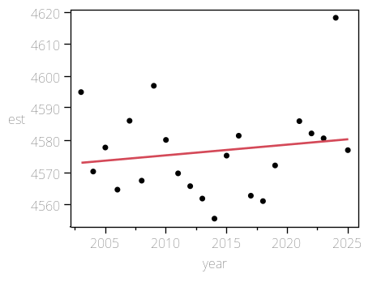

Summary of Fit

RSquare | 0.025167
RSquare Adj | -0.02357
Root Mean Square Error | 14.46126
Mean of Response | 4576.589
Observations (or Sum Wgts) | 22

AICc | 185.2146
BIC | 187.1544

Analysis of Variance

Source | DF | Sum of Squares | Mean Square | F Ratio
Model | 1 | 107.9793 | 107.979 | 0.5163
Error | 20 | 4182.5625 | 209.128 | Prob > F
C. Total | 21 | 4290.5418 |  | 0.4807

Parameter Estimates

Term | Estimate | Std Error | t Ratio | Prob>|t| | Lower 95% | Upper 95%
Intercept | 3906.2258 | 932.9293 | 4.19 | 0.0005* | 1960.1695 | 5852.2822
year | 0.3328969 | 0.463282 | 0.72 | 0.4807 | -0.633493 | 1.2992868

coord=Y, species=longnose, area=North of Cape Mendocino

Regression Plot
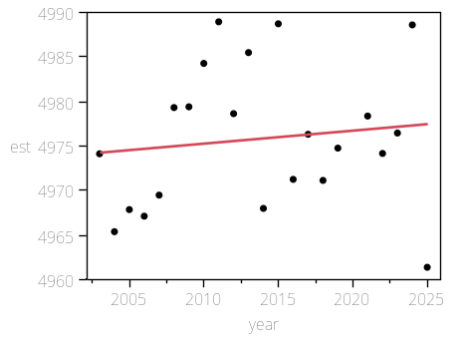

Summary of Fit

RSquare | 0.015754
RSquare Adj | -0.03346
Root Mean Square Error | 8.051976
Mean of Response | 4975.813
Observations (or Sum Wgts) | 22

AICc | 159.4502
BIC | 161.39

Analysis of Variance

Source | DF | Sum of Squares | Mean Square | F Ratio
Model | 1 | 20.7552 | 20.7552 | 0.3201
Error | 20 | 1296.6862 | 64.8343 | Prob > F
C. Total | 21 | 1317.4415 |  | 0.5778

Parameter Estimates

Term | Estimate | Std Error | t Ratio | Prob>|t| | Lower 95% | Upper 95%
Intercept | 4681.9097 | 519.4514 | 9.01 | <.0001* | 3598.353 | 5765.4663
year | 0.1459497 | 0.257954 | 0.57 | 0.5778 | -0.392132 | 0.6840319

coord=Y, species=longnose, area=North of Monterey Bay

Regression Plot
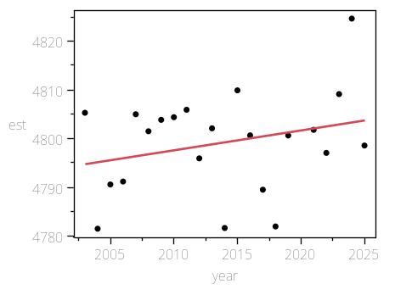

Summary of Fit

RSquare | 0.073215
RSquare Adj | 0.026876
Root Mean Square Error | 10.12717
Mean of Response | 4799.157
Observations (or Sum Wgts) | 22

AICc | 169.5396
BIC | 171.4793

Analysis of Variance

Source | DF | Sum of Squares | Mean Square | F Ratio
Model | 1 | 162.0417 | 162.042 | 1.5800
Error | 20 | 2051.1899 | 102.559 | Prob > F
C. Total | 21 | 2213.2317 |  | 0.2232

Parameter Estimates

Term | Estimate | Std Error | t Ratio | Prob>|t| | Lower 95% | Upper 95%
Intercept | 3977.9487 | 653.3267 | 6.09 | <.0001* | 2615.133 | 5340.7644
year | 0.4078053 | 0.324435 | 1.26 | 0.2232 | -0.268954 | 1.0845644

coord=Y, species=longnose, area=OR

Regression Plot
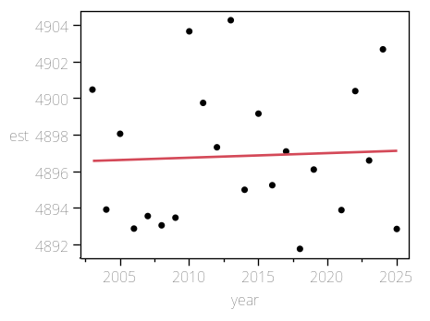

Summary of Fit

RSquare | 0.002072
RSquare Adj | -0.04782
Root Mean Square Error | 3.830477
Mean of Response | 4896.849
Observations (or Sum Wgts) | 22

AICc | 126.7613
BIC | 128.7011

Analysis of Variance

Source | DF | Sum of Squares | Mean Square | F Ratio
Model | 1 | 0.60915 | 0.6091 | 0.0415
Error | 20 | 293.45104 | 14.6726 | Prob > F
C. Total | 21 | 294.06019 |  | 0.8406

Parameter Estimates

Term | Estimate | Std Error | t Ratio | Prob>|t| | Lower 95% | Upper 95%
Intercept | 4846.4989 | 247.1128 | 19.61 | <.0001* | 4331.0306 | 5361.9673
year | 0.0250035 | 0.122713 | 0.20 | 0.8406 | -0.230972 | 0.2809793

coord=Y, species=longnose, area=South of Cape Mendocino

Regression Plot
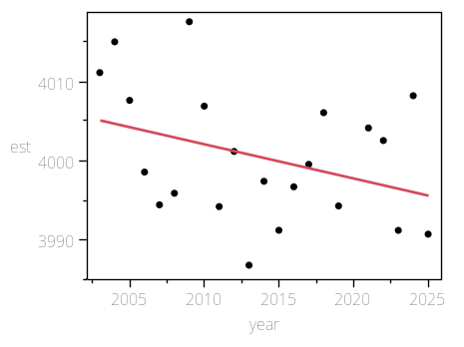

Summary of Fit

RSquare | 0.126692
RSquare Adj | 0.083026
Root Mean Square Error | 7.910839
Mean of Response | 4000.431
Observations (or Sum Wgts) | 22

AICc | 158.6721
BIC | 160.6119

Analysis of Variance

Source | DF | Sum of Squares | Mean Square | F Ratio
Model | 1 | 181.5746 | 181.575 | 2.9014
Error | 20 | 1251.6274 | 62.581 | Prob > F
C. Total | 21 | 1433.2019 |  | 0.1040

Parameter Estimates

Term | Estimate | Std Error | t Ratio | Prob>|t| | Lower 95% | Upper 95%
Intercept | 4869.7268 | 510.3464 | 9.54 | <.0001* | 3805.1629 | 5934.2906
year | -0.431685 | 0.253432 | -1.70 | 0.1040 | -0.960336 | 0.0969655

coord=Y, species=longnose, area=South of Monterey Bay

Regression Plot
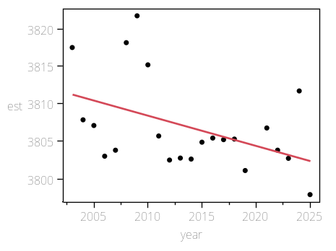

Summary of Fit

RSquare | 0.201565
RSquare Adj | 0.161644
Root Mean Square Error | 5.608393
Mean of Response | 3806.904
Observations (or Sum Wgts) | 22

AICc | 143.5374
BIC | 145.4772

Analysis of Variance

Source | DF | Sum of Squares | Mean Square | F Ratio
Model | 1 | 158.81195 | 158.812 | 5.0490
Error | 20 | 629.08145 | 31.454 | Prob > F
C. Total | 21 | 787.89340 |  | 0.0361*

Parameter Estimates

Term | Estimate | Std Error | t Ratio | Prob>|t| | Lower 95% | Upper 95%
Intercept | 4619.8875 | 361.8103 | 12.77 | <.0001* | 3865.1644 | 5374.6105
year | -0.403721 | 0.179671 | -2.25 | 0.0361* | -0.778508 | -0.028934

coord=Y, species=longnose, area=WA

Regression Plot
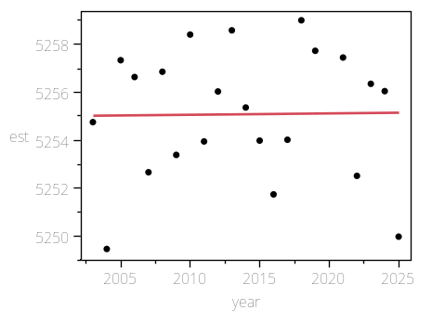

Summary of Fit

RSquare | 0.000206
RSquare Adj | -0.04978
Root Mean Square Error | 2.768531
Mean of Response | 5255.083
Observations (or Sum Wgts) | 22

AICc | 112.4758
BIC | 114.4155

Analysis of Variance

Source | DF | Sum of Squares | Mean Square | F Ratio
Model | 1 | 0.03160 | 0.03160 | 0.0041
Error | 20 | 153.29531 | 7.66477 | Prob > F
C. Total | 21 | 153.32691 |  | 0.9494

Parameter Estimates

Term | Estimate | Std Error | t Ratio | Prob>|t| | Lower 95% | Upper 95%
Intercept | 5243.615 | 178.6043 | 29.36 | <.0001* | 4871.0529 | 5616.177
year | 0.0056951 | 0.088693 | 0.06 | 0.9494 | -0.179315 | 0.1907053

